**WEare**

**SOCIAL NETWORK**

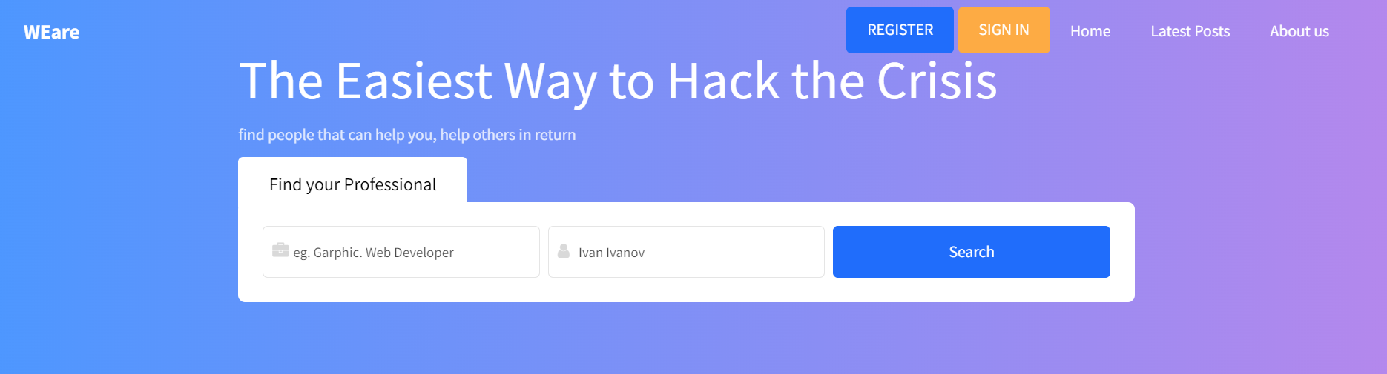

**Delivered to you by:**

**Team4{win}**

Aneliya Boneva,

Boris Yurukov,

Dinko Atanasov

**https://github.com/Alpha-50-group-4-final-project/Group-4-common-repo/tree/main**

**Table of contents**

1. **Overview**
   1. **Purpose**
   2. **Objectives**
   3. **Tasks**
   4. **Pre-conditions**
2. **System under test**
   1. **Application focus area**
   2. **SUT map**
3. **Scope of testing**
   1. **Functionalities to be tested**
   2. **Functionalities not to be tested**
4. **Testing Types**
   1. **Functional testing**
   2. **Non-functional testing**
   3. **Test Automation**
5. **Entry Criteria**
6. **Exit Criteria**
7. **Environment**
8. **Test Tools**
9. **Reporting**
10. **Roles and Responsibilities**
11. **Schedule**
12. **Attachments**

**Overview**

## **Purpose**

The purpose of this document is to describe the plan for testing **WEare social network** – application that enables users to: connect with people; create, comment and like posts; get a feed of the newest/most relevant posts of user’s connections. This document aims to define the strategy, approach, roles and responsibilities of the parties involved in the process of testing the new web-based application. It describes what will be tested, by whom, resources required and the time frame needed.

## **Objectives**

The main objective of the test process is to verify the **WEare social network** works as expected, client’s needs are met, severity 1(Blocking) and severity 2(Major) bugs are reported and properly handled and to report any deviation from the original plan to the product owners.

The main objectives of the test plan are as follows:

* Identify the scope of testing
* Define all the necessary pre-conditions
* Identify resources needed – QA personnel, software and hardware requirements, timeframe
* Define clear responsibilities and chain of report
* Identify test techniques and best practices to be used

## **Tasks**

Detailed test cases (with Title, Narrative, Precondition, Tests Steps, Expected Result, and Priority) will be written for the critical functionalities, such as registration, login, public usage of the web application, etc.

Detailed test cases will not be written for low risk and non-critical functionality.

Tests executed will be logged and reported upon on a daily basis.

Weekly OPS meeting and respective reports to be concluded at the end of each week. Ad-hoc meeting to be scheduled if necessary.

## **Pre-conditions**

Software is being delivered in multiple sprints, each lasting 14 days. Prior to releasing the **WEare social network** for integration, system and user acceptance testing, the Dev team will conduct unit tests on each sprint.

**System under test**

## **Application Focus Areas**

**Registration and Login:** App allows you to register, login and use all of the app’s features.

**Connecting People:** Functionality for sending, accepting friend requests and disconnect from users.

**Post Creation and Interaction:** Ability to create, comment, and like posts.

**Feed Algorithm:** Feed populates based on new posts and user connections.

**Service Exchange:** Platform allows users to set their profession/skills and make service-offering posts.

## **SUT – map**

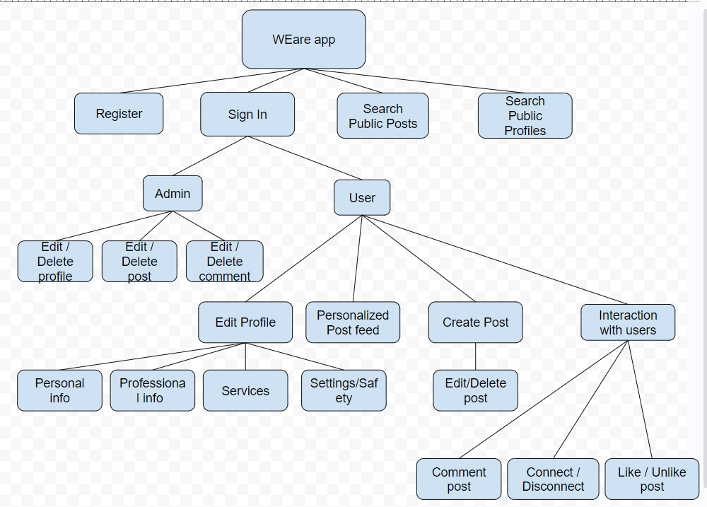

**Scope of testing**

The scope of this Test Plan includes UI as well as API testing. The evaluation will follow the DEV’s team requirements that have been described in details in attached document: [Social Network Project Specification](requirements/Social%20Network%20Project%20Specification.docx). Starting with the “must have” features as crucial part of the project development.

## **Functionalities to be tested**

* **Role**: Not logged User
  + Registration form
  + Login form
  + Using the app as anonymous user – posts and profile search
* **Role**: Logged in User
  + Edit user’s profile – update personal and professional information
  + Post and Comment creation - with text and image
  + Connect to user – sending and accepting friend request, disconnecting from user
* **Role**: Logged in Admin
  + Enable/Disable profile
  + Edit other user’s profile
  + Edit/Delete post
  + Edit/Delete comment

**Functionalities not to be tested**

* **Role: Not logged**
  + Registration – email and identity verification
* **Role: Logged in User**
  + Change password, email, additional details
  + Post creation - add song, video, location
  + Complex algorithm for post generation
* **Role: Logged in Admin** – n/a

**Testing types**

1. Functional testing

## **Smoke Testing**

Build verification testing to cover the main functionalities of the web application will be perform upon beginning of actual testing. The main purpose is to confirm that the DEV’s work is done and the QA team can proceed with further software testing.

## **Exploratory testing**

Purpose of this exploratory testing is to simultaneously run through the web application in order for the QA team to make familiar with its interface, design, functionalities and identify issues in the most common User scenarios. Ideas, observations and actual behaviours should be recorded: do the system and feature under test seem to be stable? Based on the feedback gained updates may be performed and additional testing types may need to be added on the current ‘’Test types’’ section.

## **Regression testing**

Regression testing will be performed in order to verify that no issues were introduces in the most important functionalities after a change made on the environment. The execution of those test should be very time-sensitive so that we can receive rapid feedback on the website status after each check-in.

1. Non-functional testing

## **Security testing**

Non-functional web security testing will be partly executed and be done by an automated tool or the tester knowledge for security. Tests will be performed for OWASP **Top 10 Most Critical Web Application Security Risks**

Upon client’s request, a specialised security QA tester/third party organization may be hired and assigned for extensive security testing. In that scenario an update on the budget will have to be further discussed and approved.

**Cross-browser testing**

The behaviour of the **WEare social network** must be tested against different browsers. As per approved requests from client’s side the **WEare social network** application must be compatible with the following browsers:

* Chrome, version 116 and newer
* Edge, version 110 and newer
* Mozilla Firefox, version 108 and newer

In order to maximize client’s requirements browsers listed above must be tested on both Android and iOS platforms

**Responsive testing**

For better customer satisfaction and in order to enable **WEare social network** to scale its content and related page components automatically across different devices, a responsive testing should be perform. This will enhance customer’s experience no matter what device they choose to use. The variety of screen sizes, device configuration and other factors will be decided upon beginning of testing depending on the time left for testing. Online Web Browser Emulators to be used.

## **Performance testing**

Get a report form marketing that contains:

* Load time of the Home page, Navigation, Search, Post creation, Friend request;
* Average users count per minute/hour/day.

The tests should be run with limited number of concurrent users. The goal is to create load time statistics that are as close to the real one as possible. Test will be performed on the Development environment to identify possible bottlenecks early in development. The behaviour of the system under load is subject of the Load Testing (see next section).

## **Stress and Load testing**

Get a report from marketing that contains:

* Maximum concurrent users on the website;
* Average concurrent users count per hour;
* Threshold of user satisfaction in term of page load time.

Test should simulate multiple User scenarios on the website mixed in the test run. Should include Performance counters from the webserver and the SQL server.

## **User acceptance testing**

The purpose of User Acceptance testing is to determine whether the acceptance criteria specified by the Product owner are covered before the release. These tests can only start after previous testing have been successfully completed and an accepted number and severity of bugs stays unresolved. This section will be performed by the Product owner/s of the product and a member from the QA team that can take notes of the user interaction, issues or questions that need further follow up.

The following question must be answered:

* Is the functionality fulfilling the business goal?
* How easy can the user navigate and interact with the system?
* Is there anything confusing?
* Are the acceptance criteria covered?

## Test Automation

During each sprint it will be decided which test cases will be automated having in mind possibilities and efficiency. Happy paths to be automated with priority. Automated tests will be used for executing automated regression and smoke tests. Test automation will be done on test cases that successfully passed the manual tests and have no blocking or critical issues opened.

## **Entry Criteria**

* Test plan (first draft) , designs and approvals are ready
* The Test environment is available and ready for use.
* Test tools installed in the environment are ready for use.
* Testable code is available and/or API endpoints ready for testing.
* Test cases for Priority: Highest & High functionalities are ready.

## **Exit Criteria**

* All Priority: Highest tests cases planned have been run.
* Priority: High have been covered at 80%
* No blocking and major severity defects that are left outstanding.
* No more bugs found.
* Deadlines not met – deadline 19/10/2023

**Priority Levels:**

|  |  |  |
| --- | --- | --- |
| 1 | Highest | The app must provide this feature to be functional. |
| 2 | High | The app may function but would cause challenges and inconveniences to the users. |
| 3 | Medium | The app can function, but the feature may improve system usage. |
| 4 | Low | Cosmetic feature related to customer’s preferences and usability. |
| 5 | Lowest | Enhancement. |

**Environment**

Based on the information gathered by Marketing and Product Owner requirements, the responsiveness of the **WEare social network** will be tested on the following devices and OS:

* Mobile device –iOS and Android 9 and above
* PCs – Windows 10 and above, Linux, MacOS
* Docker – as deployment environment for the purpose of testing.

## **Test tools**

* Jira-Project and defect tracking tool;
* X-ray for Jira – Test case management tool;
* Google Chrome as browser;
* Java 11 – as programming language;
* IntelliJ IDEA – Integrated Development Environment ;
* Selenium WebDriver – development automation test scripts;
* Postman - as API platform
* Junit
* GitHub - repository platform;
* JMeter Apache

Other tools may be used during the testing process. In such case development team will be informed.

**Reporting**

All defects found will be described, stored and shared in specifically created project in Jira. Bug template provided to unify bug reports: [Team4{win} - Bug_template.docx](Team4%7bwin%7d%20-%20Bug_template.docx) Bug issues’ status must be always up to date. Results must be stored in a maintainable format, easy to be reviewed and analysed.

Test reports will be shared to Product manager and Product Owner in a weekly bases during regular meetings or via email.

System used for progress review, test cases execution and defect tracking will be Jira. Project: team4tests.atlassian.net .

Systems used for reporting will be Allure and Newman. Reports available at: <https://github.com/Alpha-50-group-4-final-project/Group-4-common-repo/tree/main>

**Severity Levels:**

|  |  |  |
| --- | --- | --- |
| 1 | Blocking | Blocking development and/or testing. |
| 2 | Major | Critical problem that prevents the app from working properly. |
| 3 | Medium | A loss of functionality for a wide range of features. |
| 4 | Minor | Minor loss of functionality or other problem where easy workaround is present. |
| 5 | Trivial | UI glitch that doesn’t affect the app running. |

## **Roles and Responsibilities**

|  |  |  |
| --- | --- | --- |
| ROLE: | **NAME AND EMAIL:** | **RESPONSIBILITIES:** |
| Project manager | Pikachu@abc.com | Manage the whole project and coordinates the parties involved |
| Product Owner | [Harry.Potter @client.com](mailto:Ash.Ketchum@client.com) | Approvals |
| QA manager | Snoop.Dog @abc.com | Coordination and assistance |
| Business analyst | Madonna@abc.com | Documentation and planning |
| QA tester | aneliya.boneva.a50@learn.telerikacademy.com | Performs Exploratory, Regression and Automation testing, non-functional testing |
| QA tester | boris.yurukov.a50@learn.telerikacademy.com | Performs Exploratory, Regression and Automation testing, non-functional testing |
| QA tester | dinkoatanasov1@gmail.com | Performs Exploratory, Regression and Automation testing, non-functional testing |

## **Schedule**

|  |  |  |  |  |
| --- | --- | --- | --- | --- |
| **Branch** | **Task** | **Member** | **Days for execution** | **Time period** |
| **Organisational** | Shared drive | Dinko | 2 | 15-Sept - 17-Sept |
|  | Shared GitHub | Boris | 2 | 15-Sept - 17-Sept |
|  | Docker installation | everyone | 2 | 15-Sept - 17-Sept |
|  | Jira set up | Aneliya | 2 | 15-Sept - 17-Sept |
| **Documentations** | Test Plan creation | everyone | ~ | 18-Sept - ongoing |
|  | Test scenarios/overview | Dinko | 4 | 15-Sept-18-Sept |
|  | Test cases creation | everyone | 10 | 18-Sept-28-Sept |
|  | Reporting | everyone |  |  |
| **Testing** | Exploratory testing | everyone | 3 | 18-Sept-20-Sept |
|  | Manual testing | everyone | 9 | 20-Sept-28-Sept |
|  | Automation testing: |  |  |  |
|  | *UI testing | everyone | 7 | 22-Sept-29-Sept |
|  | *Postman | everyone | 8 | 29-Sept-6-Oct |
|  | *Rest Assured | everyone | 12 | 29-Sept-10-Oct |
| **Re-testing** | Smoke testing | everyone | 9 | 10-Oct-19-Oct |
| **Optional** | *non-functional testing | everyone | 9 | 10-Oct-19-Oct |

## **Attachments**

[Team4{win} - Test Cases Template.docx](Team4%7bwin%7d%20-%20Test%20Cases%20Template.docx)

[Team4{win} - Bug_template.docx](Team4%7bwin%7d%20-%20Bug_template.docx)

[Team4{win} - Test cases_v354.xlsx](Team4%7bwin%7d%20-%20Test%20cases_v354.xlsx)

[Team4{win} - Time Schedule.xlsx](Team4%7bwin%7d%20-%20Time%20Schedule.xlsx)